Password Strength Checker
(Cyber Security Awareness Project)

1.Introduction
:- Cyber Security Awareness is the practice of educating people about online threats and how to stay safe in the digital world. In today’s time, almost every person uses the internet for social media, banking, shopping, and communication. Because of this, personal data security has become very important.
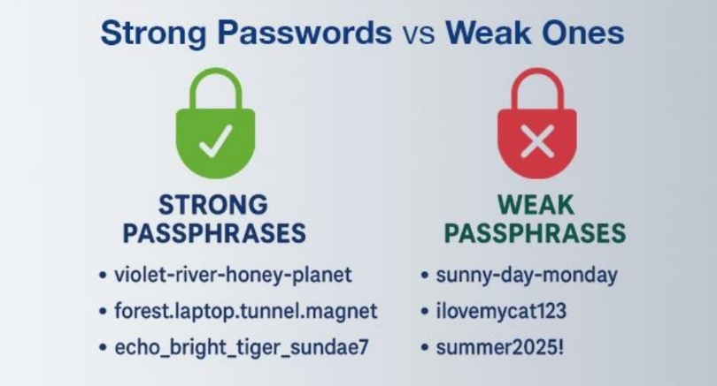
:- One of the most common mistakes users make is creating weak passwords such as "123456", "password", or their own name. These passwords are very easy for hackers to guess. This project focuses on solving this issue by helping users understand how to create strong and secure passwords.
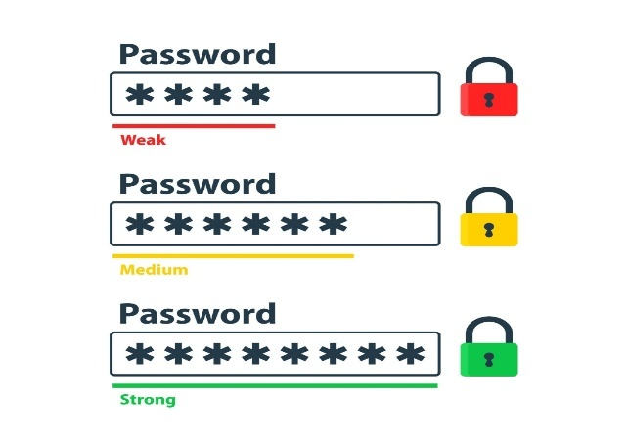
2. Problem Statement
Many users are not aware of the importance of strong passwords. Due to this lack of awareness:
- Accounts can be easily hacked
- Sensitive information can be stolen
- Financial loss may occur
- Identity theft can happen
There is a strong need for a system that can guide users in choosing safe passwords and alert them when their password is weak.

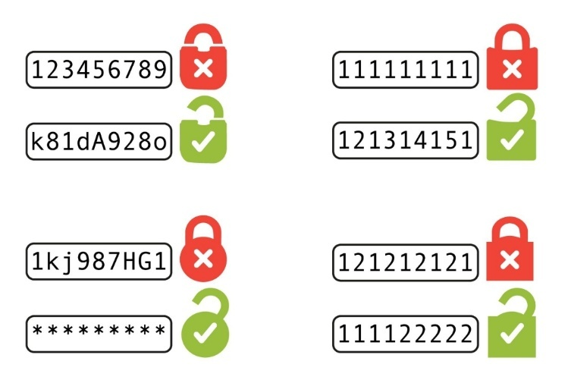

3. Project Idea
The main idea of this project is to develop a Password Strength Checker tool. This tool will:
- Analyze the entered password
- Classify it as Weak, Medium, or Strong
- Provide suggestions to improve password strength
For example:
- Weak Password: “kunal123”
- Medium Password: “Kunal@12”
- Strong Password: “K@nal#2026!”

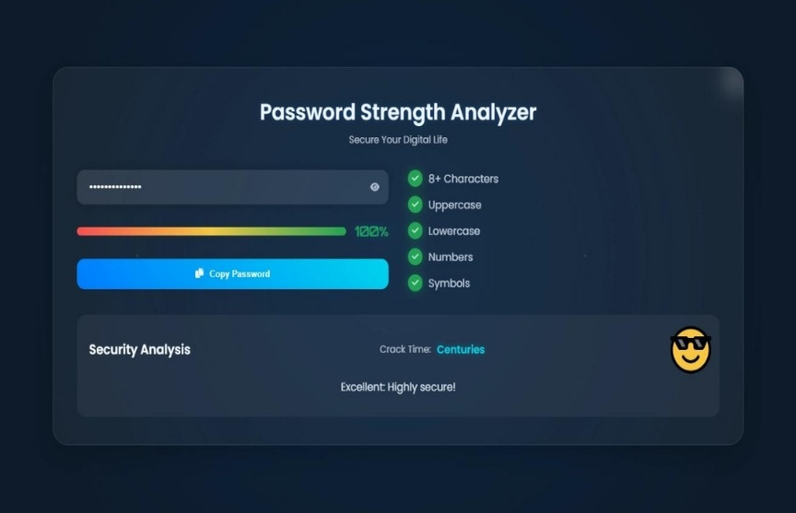
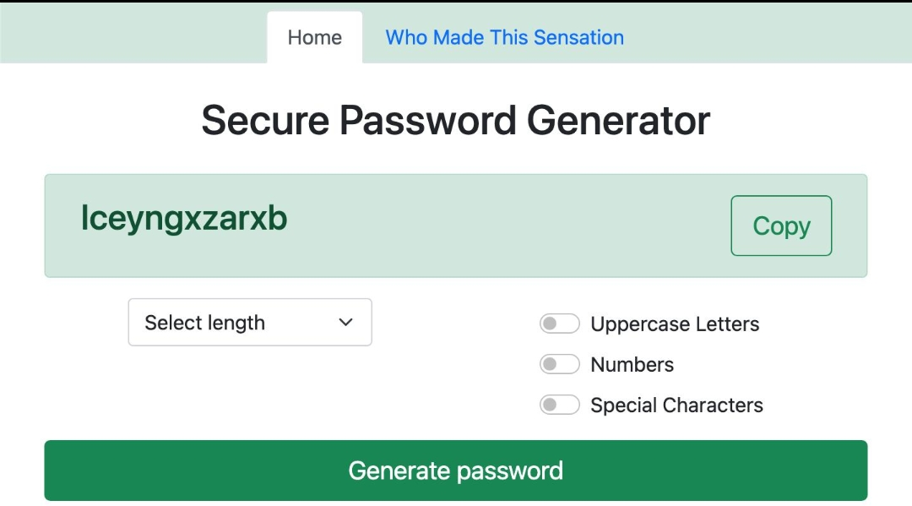
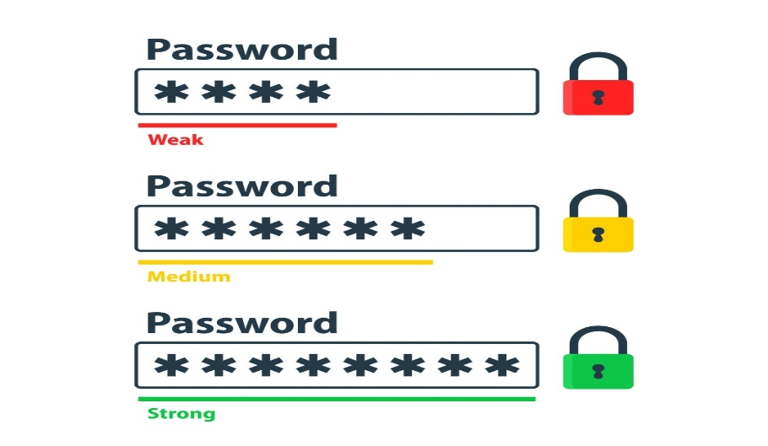

4. Working of the Project
The working of the Password Strength Checker is based on a set of rules:
- Length Check – Password should be at least 8 characters long
- Uppercase Letters – At least one capital letter (A–Z)
- Lowercase Letters – At least one small letter (a–z)
- Numbers – At least one numeric value (0–9)
- Special Characters – Symbols like @, #, $, %, etc.
- Common Password Detection – Avoid commonly used passwords
Based on these checks, the system gives a score:
- 0–3 points → Weak
- 4–6 points → Medium
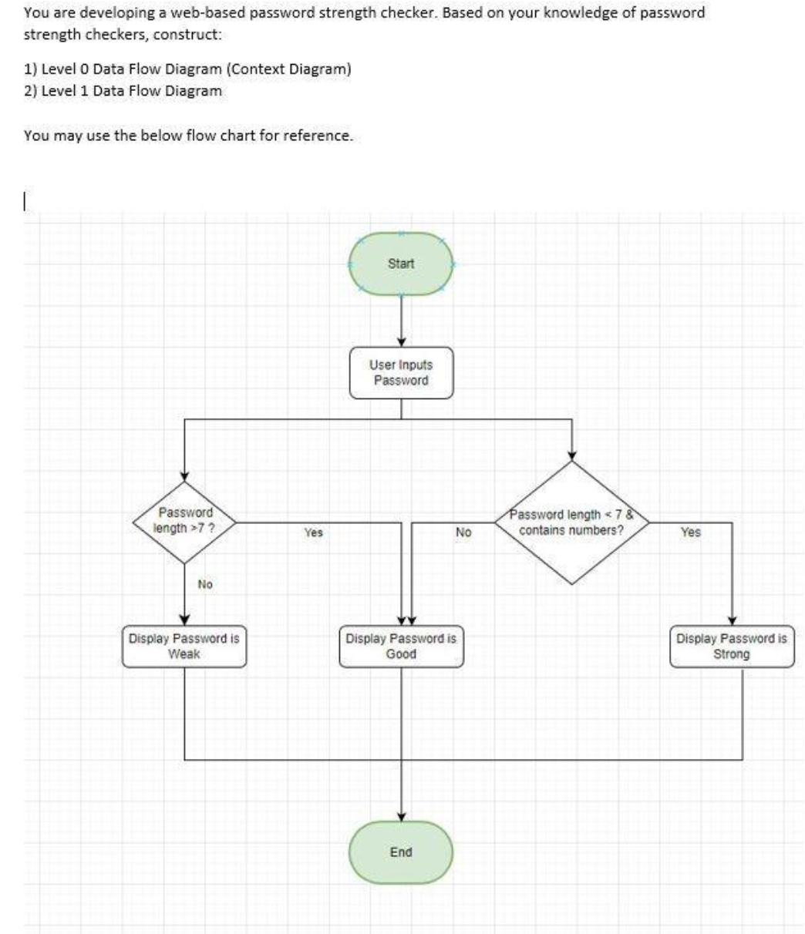
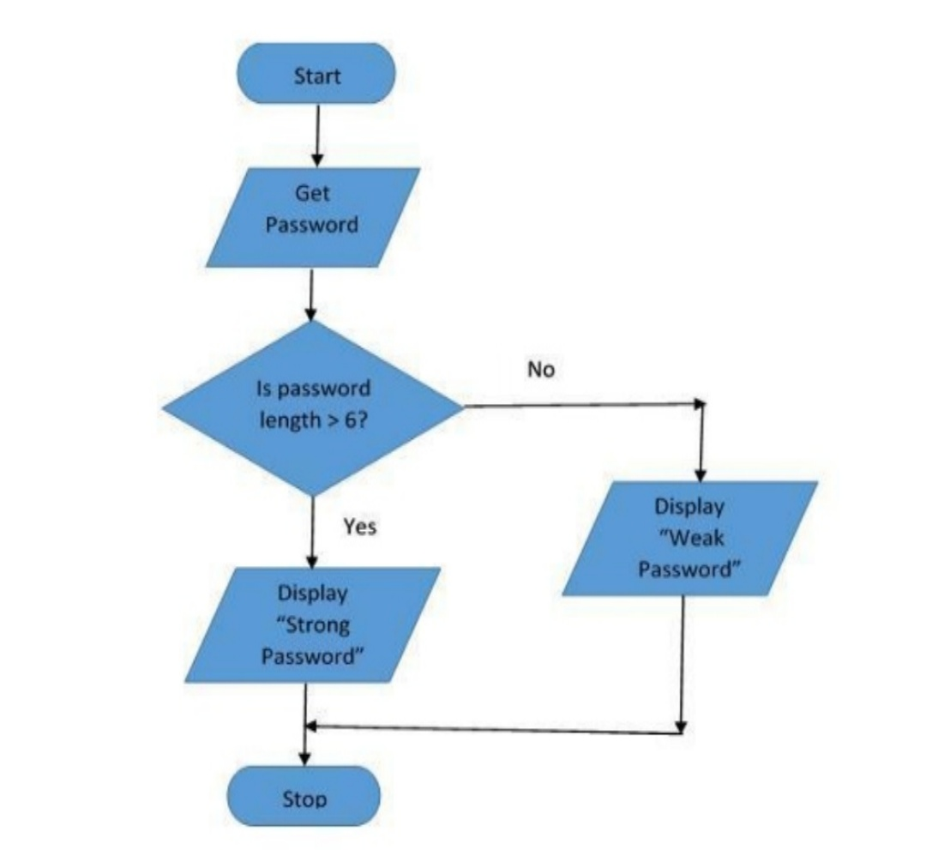
- 7+ points → Strong
5. Technologies Used
The following technologies are used to build this project:
- HTML (Hyper Text Markup Language) – To create the structure of the web page
- CSS (Cascading Style Sheets) – To design and style the interface
- JavaScript / Python – To implement the logic of password checking
Optional tools:
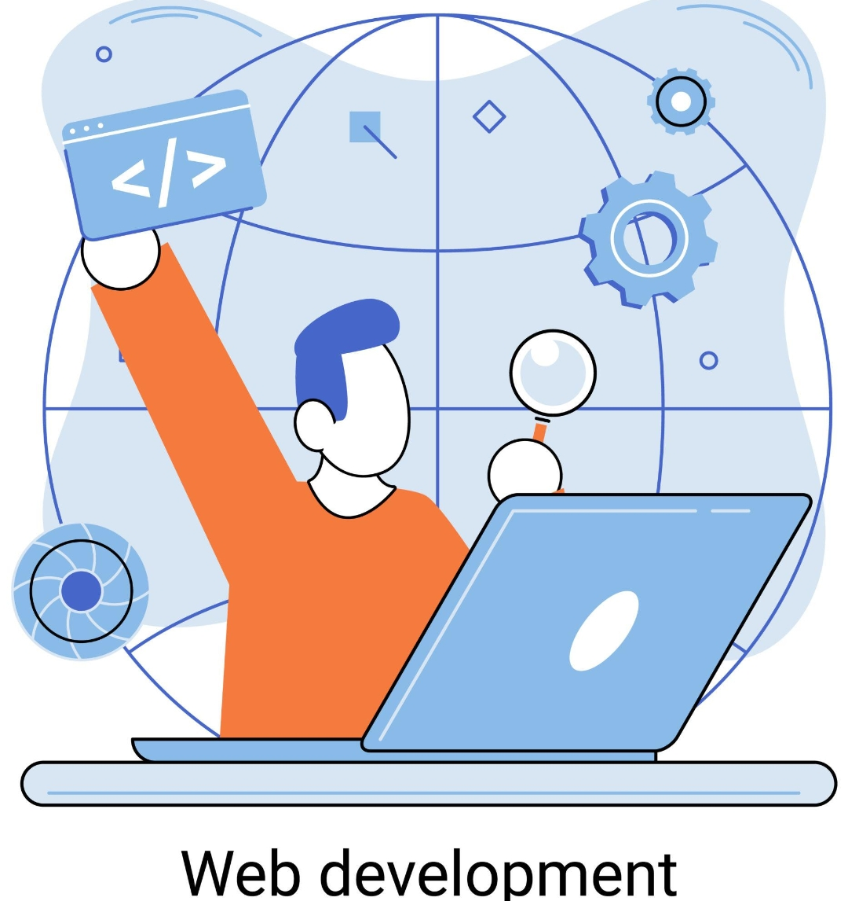


- Database (to store user data if needed)

6. Features of the Project
This project includes several useful features:
✔ Real-time password strength checking
✔ Visual indicators (Red, Yellow, Green)
✔ Suggestions for improving weak passwords
✔ Easy-to-use interface
✔ Fast and accurate results
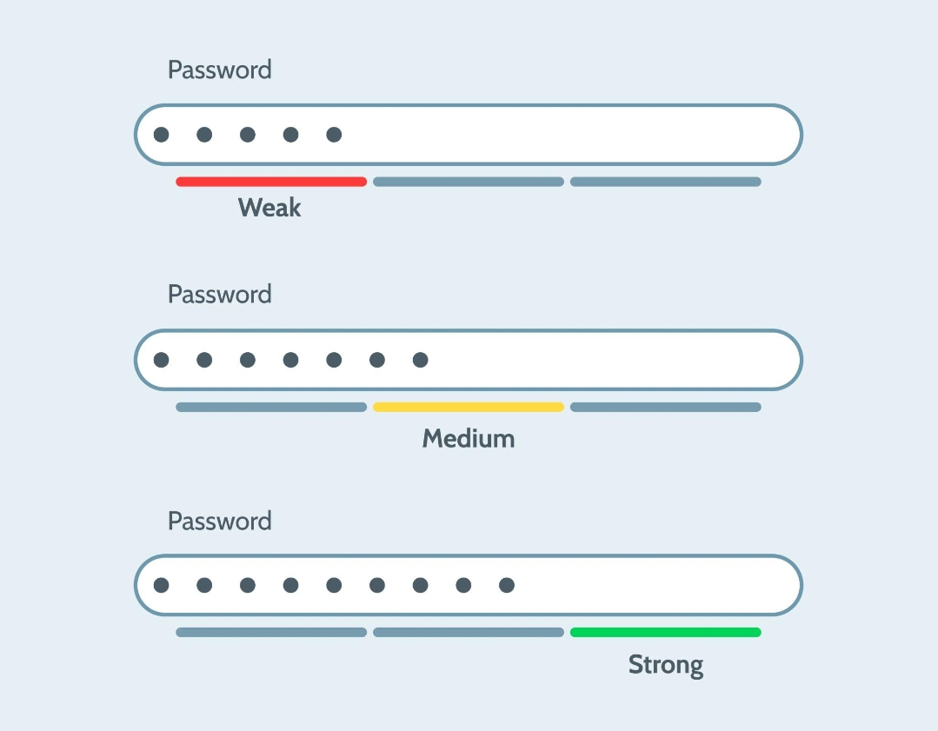
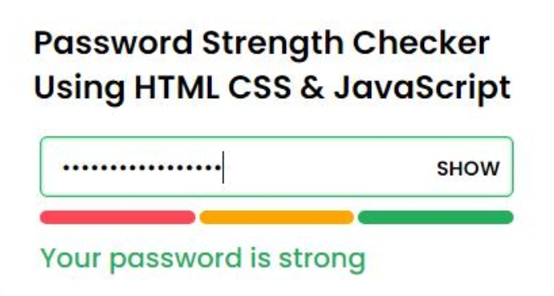
7. Advantages
The advantages of this project are:
- Helps users create strong passwords
- Reduces chances of hacking
- Protects personal and financial data
- Increases awareness about cyber security
- Easy to use for beginners



8. Limitations
Despite its benefits, the project has some limitations:
- Users may forget complex passwords
- Some users reuse the same password for multiple accounts
- The tool cannot prevent all types of cyber attacks
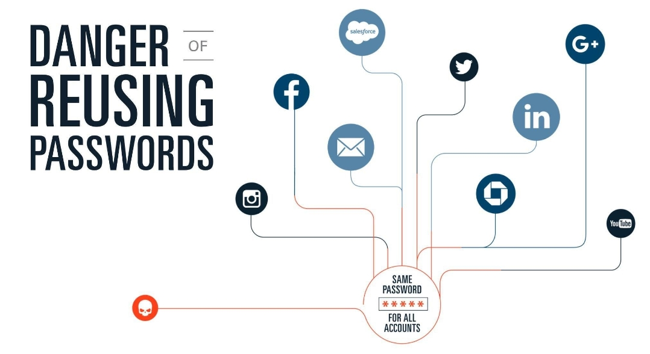
- It depends on user behavior.

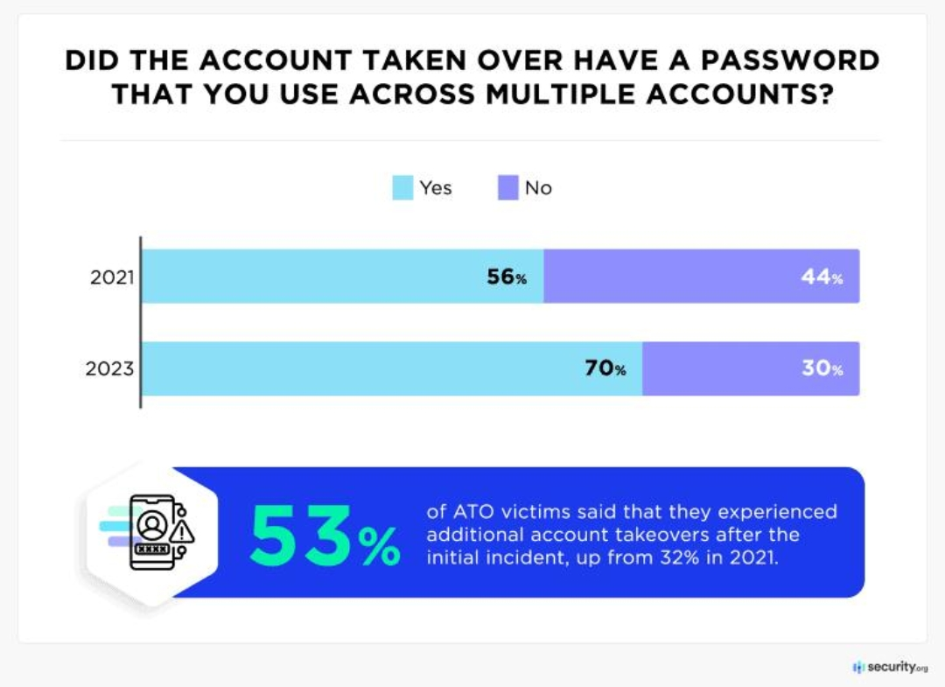
9. Conclusion
In conclusion, the Password Strength Checker is a simple yet powerful tool that improves online safety. It helps users understand the importance of strong passwords and guides them in creating secure ones.

In today’s digital world, where cyber threats are increasing rapidly, using strong passwords is the first and most important step toward protecting personal information and staying safe online.


Github link (https://github.com/Kuldeep-123-create/Kuldeep-.git)

